OOP-LAB Task 2

Roll No: 24P-0706 | Dept: BS-CS
Name: Aazan Noor Khuwaja | Section : 2D

Qns1:
#include<iostream>
using namespace std;
int main()
{
int n,count=0;
bool palindro=true;
cout <<"The size of string :"<<endl;
cin>>n;
char *a=new char[n+1];
cout <<"Enter any word which should not have any space and should be less then: "<<n<<" characters."<<endl;

for(int i=0;i<n;i++){
cin>>*(a+i);
}

for(int i=0;i<n/2;i++)
{
if(*(a+i) != *(a+n-i-1)){
palindro=false;
break;
}
}
if(palindro)
{
cout <<"The array is Palindrome."<<endl;
}
else{
cout <<"The array is not palindrome."<<endl;
}
char ch;
cout <<"Enter the character to count its frequency."<<endl;
cin>>ch;
for (int i=0;i<n;i++)
{
if(*(a+i) == ch)
{
count++;
}
}
cout <<"The Frequency of this character in the string is:"<<count<<endl;
delete[] a;
return 0;
}

Output:
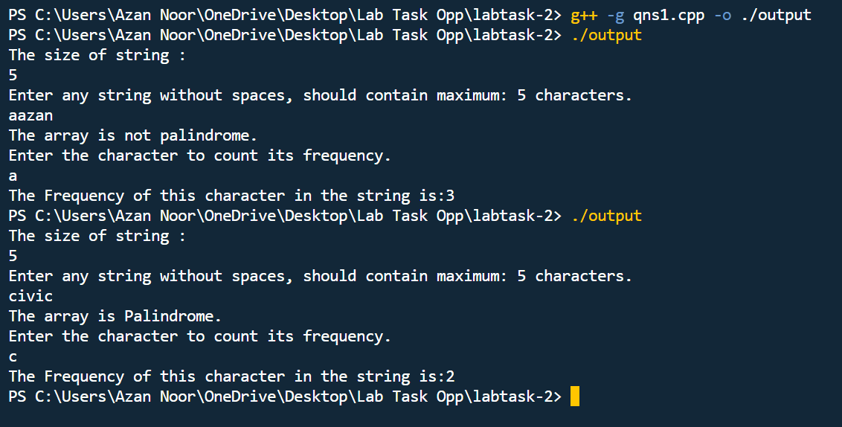

Qns 2:
#include<iostream>
using namespace std;
int main()
{
int row_s,col_s,sum=0;
cout <<"enter number of rows you want:"<<endl;
cin>>row_s;
cout<<"Enter number of coloums you want:"<<endl;
cin>>col_s;
int **a=new int*[row_s];
for(int i=0;i<row_s;i++)
{
a[i]=new int[col_s];
}
for(int i=0;i<row_s;i++)
{
for(int j=0;j<col_s;j++)
{
cout <<"Enter the elements of 2d array : ";
cin>>a[i][j];
}
}
int first=a[0][0],least=a[0][0];
for(int i=0;i<row_s;i++)
{
for(int j=0;j<col_s;j++)
{
sum+=a[i][j];
if(first<a[i][j])
{
first=a[i][j];
}
if(least>a[i][j])
{
least=a[i][j];
}
}
}

cout <<"The Sum OF elements of 2d array is :"<<sum<<endl;
cout<< "\nThe maximum element in this 2d array is :"<<first<<endl;
cout <<"\nThe minimum number in this 2d array is :"<<least<<endl;
cout<<"\n\n\nThe matrix before transpose."<<endl;
for(int i=0;i<row_s;i++)
{
for(int j=0;j<col_s;j++)
{
cout <<a[i][j]<<" ";
}
cout <<endl;
}
cout <<"The transpose matrix is: "<<endl;
for(int i=0;i<col_s;i++)
{
for(int j=0;j<row_s;j++)
{
cout <<a[j][i]<<" ";
}
cout<<endl;
}
for(int i=0;i<row_s;i++)
{
delete[] a[i];
}
delete[] a;

return 0;
}

Output:
